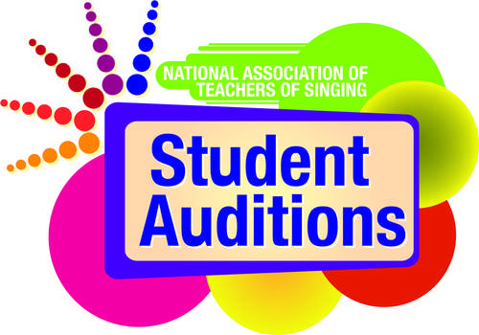

NATS Student Auditions Media Release Template
Media releases are important tools in sharing news and information about happenings and events taking place in your NATS chapter, district or region. They allow the creator to package all important facts and details into a single document that can be easily shared and distributed, forming an important piece of the communication cycle.

Once completed, media releases should be distributed far and wide – via media outlets, campus news organizations, campus PR/marketing offices, email, social media, websites, on bulletin board, and anywhere else that the news might be useful and easily accessed by the target audience. Keep the facts simple and remember to included the Who, What, When, Where and Why in any document.

To assist in this effort, NATS has created two media release templates for use by chapters, districts and regions as they promote NATS Student Audition events. One template offers a preview of the NATS Student Auditions event, while the other is a template for reporting results after the event concludes. Adjust these templates as needed and add any information that reflects the uniqueness of your local event.

Feel free to contact Paul Witkowski (paul@nats.org, 904-992-9101) at the NATS National Office with any questions.
Purpose These media release templates have been designed to help NATS chapters, districts and regions disseminate information via news media about the various rounds of NATS Student Auditions.
Format These tools provide easy fill-in blocks for localized information to be added. The instructions for completing each section of the press release are in the dark gray boxes. Users need only to type in the gray box to delete the existing text and add the information relevant to their local events.
Audience This tool is designed to be distributed to local media outlets, campus media outlets, campus news and information bureaus, campus media relations offices, and as a template for news and information shared via chapter, district or region websites. The tools can also be adapted for other NATS purposes and the general public.
Resources Information about the event you plan to publicize using a media release.
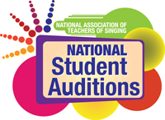
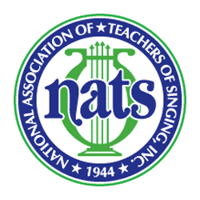

Chapter, District, Region Logo Here
(or delete this box)

For more information:
Contact Name, Phone Number, Email Address

For Immediate Release
7/28/2017

NATS Student Auditions scheduled for ... Headline will go here

Additional details and information will go here ... subhead information

CITY, State — August 7, 2017 — More than [number] singers will participate in this year’s NATS [Chapter, District or Region Name Here] Student Auditions when they are held on [Day of Week, Month, Day] at [Name of University and/or location].
Singers in 14 categories will perform and receive written feedback as part of the long-standing tradition of the National Association of Teachers of Singing (NATS). NATS Student Auditions have been an integral part of the association’s 71-year history, allowing singers to receive important evaluation and teachers the opportunity to engage in meaningful dialogue with colleagues and hear a variety of musical styles through live performance.
[Add a quote here if desired].
Performances at this year’s [Chapter, District or Region Name Here] Student Auditions begin at [time am/pm] and conclude [time am/pm] with the posting of results and comments. [Add additional details here that are important: States and areas from which singers are coming. Open to the public? Cost? Website for more details? Special awards given? Prize money offered? Top places awarded?].
In order to participate in NATS Student Auditions, a singer must be a student of a current NATS member. The singer’s participation category is determined by a variety of factors – including musical style, the amount of time he or she has studied voice, age, and year in school. More than 80 NATS chapters hold NATS Student Auditions each year from the organization’s 14 regions. Top performers have an opportunity to advance to the national round of auditions. To learn more about NATS Student Auditions, visit http://www.nats.org/national_student_auditions.html.
About the National Association of Teachers of Singing (NATS)
Founded in 1944, National Association of Teachers of Singing, Inc. (NATS) is the largest professional association of teachers of singing in the world with more than 7,000 members in the United States, Canada, and more than 30 other countries. NATS offers a variety of lifelong learning experiences to its members, with workshops, intern programs, master classes and conferences, all beginning at the chapter level and progressing to national events.
Visit www.nats.org to learn more about NATS.

#########

