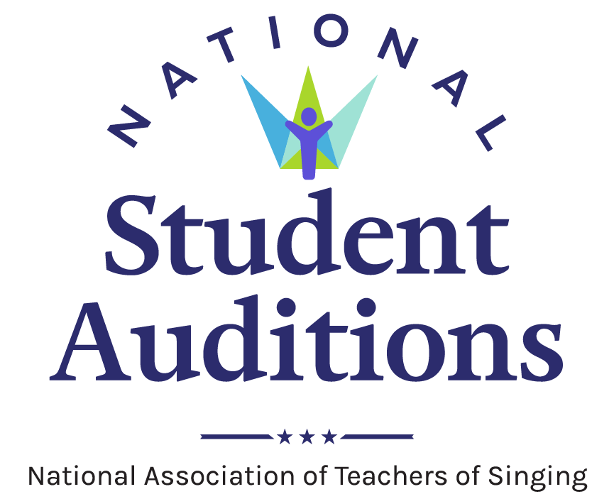
National Student Auditions Media Release Template
Media releases are important tools in sharing news and information about happenings and events taking place in your NATS chapter, district, or region. They allow the creator to package all important facts and details into a single document that can be easily shared and distributed, forming an important piece of the communication cycle.

Once completed, media releases should be distributed via media outlets, campus news organizations, campus PR/marketing offices, email, social media, websites, on bulletin boards, and anywhere else the news might be useful and easily accessed by the target audience. Keep the facts simple and remember to included the Who, What, When, Where, and Why in any document.

To assist in this effort, NATS has developed two media release templates for use by chapters, districts, and regions as they promote National Student Audition events in their area. One template offers a preview of the NATS Student Auditions event, while the other is a template for reporting results after the event concludes. Adjust these templates as needed and add any information that reflects the uniqueness of your local event.

Please contact the NATS Executive Office at info@nats.org or 904-992-9101 with any questions about these templates.
Purpose These media release templates have been designed to help NATS chapters, districts, and regions disseminate information via news media about the various rounds of NATS Student Auditions.
Format These tools provide easy fill-in areas for localized information to be added. The areas to add personalized information are yellow highlight. Once completed, select the yellow highlight with your cursor. Navigate to the “Home” tab, then on drop-down menu of highlighter, select “No color.”
Audience This tool is designed to be distributed to local media outlets, campus media outlets, campus news and information bureaus, campus media relations offices, and as a template for news and information shared via chapter, district, or region websites. The tools also may be adapted for other NATS purposes and the general public.
Resources Information about the event you plan to publicize using a media release.

For more information:
Contact Name, Phone, Email

For Immediate Release
Month-Day-Year

National Student Auditions – Chapter/Region announce schedule (headline)

Additional details go here (subhead)

CITY, State — (Month Day, Year). More than XX singers in the [insert geographic location] area will participate in the National Student Auditions offered by the National Association of Teachers of Singing (NATS).

The National Student Auditions – (insert Region/Chapter) will be held [Day of Week, Month Day] at [university or location].

Singers in XX categories will perform and receive written feedback as part of the long-standing tradition of the National Association of Teachers of Singing (NATS). National Student Auditions have been an integral part of the association’s history. The auditions allow singers to receive important adjudication feedback and teachers the opportunity to engage in meaningful dialogue with colleagues and hear a variety of musical styles through live performance.

[Optional place to insert quote from leader or organizer.]

Performances for this year’s National Student Auditions - [Chapter, District or Region name] begin at [time a.m./p.m.] and conclude at [time a.m./p.m.] with the posting of results and comments. [Add additional details here. Possibilities include: states/areas that students will represent, online/in-person, ways to watch, cost, website, special awards, prize money, etc.]

In order to participate in the National Student Auditions, a singer must be a student of a current NATS member. The singer’s participation category is determined by a variety of factors – including musical genre/style, the amount of time they have studied voice, age, and year in school. More than 80 NATS chapters hold these auditions each year from the organization’s 14 regions. Top performers in region auditions have an opportunity to advance to the national rounds of auditions. To learn more, visit nats.org.
About the National Association of Teachers of Singing (NATS)
Founded in 1944, National Association of Teachers of Singing, Inc. (NATS) is the largest professional association of teachers of singing in the world with more than 7,000 members in the United States, Canada, and more than 30 other countries. NATS offers a variety of lifelong learning experiences to its members, with workshops, intern programs, master classes, and conferences, all beginning at the chapter level and progressing to national events. Visit nats.org to learn more about NATS.

###

