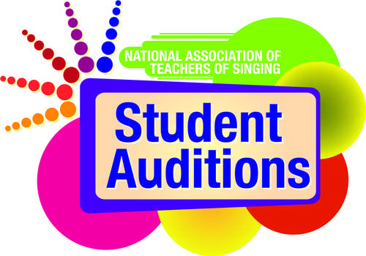

NATS Student Auditions Media Release Template
Media releases are important tools in sharing news and information about happenings and events taking place in your NATS chapter, district or region. They allow the creator to package all important facts and details into a single document that can be easily shared and distributed, forming an important piece of the communication cycle.

Once completed, media releases should be distributed far and wide – via media outlets, campus news organizations, campus PR/marketing offices, email, social media, websites, on bulletin board, and anywhere else that the news might be useful and easily accessed by the target audience. Keep the facts simple and remember to included the Who, What, When, Where and Why in any document.

To assist in this effort, NATS has created two media release templates for use by chapters, districts and regions as they promote NATS Student Audition events. One template offers a preview of the NATS Student Auditions event, while the other is a template for reporting results after the event concludes. Adjust these templates as needed and add any information that reflects the uniqueness of your local event.

Feel free to contact Paul Witkowski (paul@nats.org, 904-992-9101) at the NATS National Office with any questions.
Purpose These media release templates have been designed to help NATS chapters, districts and regions disseminate information via news media about the various rounds of NATS Student Auditions.
Format These tools provide easy fill-in blocks for localized information to be added. The instructions for completing each section of the press release are in the dark gray boxes. Users need only to type in the gray box to delete the existing text and add the information relevant to their local events.
Audience This tool is designed to be distributed to local media outlets, campus media outlets, campus news and information bureaus, campus media relations offices, and as a template for news and information shared via chapter, district or region websites. The tools can also be adapted for other NATS purposes and the general public.
Resources Information about the event you plan to publicize using a media release.

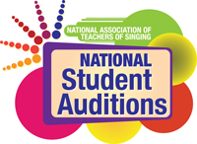
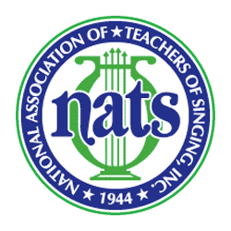

Chapter, District, Region Logo Here
(or delete this box)

For more information:
Contact Name, Phone Number, Email Address

For Immediate Release
7/28/2017

Top performers selected at NATS Student Auditions ... Headline goes here

Additional details and information will go here ... subhead information

CITY, State — August 7, 2017 — More than [number] singers participated in this year’s NATS [Chapter, District or Region Name Here] Student Auditions on [Month, Day] at [Name of University and/or location], with top performers selected in 14 categories.
Singers auditioned and received important feedback as part of the long-standing tradition of the National Association of Teachers of Singing (NATS) Student Auditions program. Various musical styles were on display during the event, from music theater repertoires, to classical repertoires, to art song selections. The top three singers were selected in each category, as selected by a panel of three judges. [Add prize, scholarship, or other information here, if applicable or desired.]
[Add a quote here if desired].

Top performers by category include:
1 – High School Music Theater Women – [Name of winner, School or Hometown]
2 – High School Music Theater Men – [Name of winner, School or Hometown]
3 – High School Women – [Name of winner, School or Hometown]
4 – High School Men – [Name of winner, School or Hometown]
5 – Lower College Music Theater Women – [Name of winner, School or Hometown]
6 – Lower College Music Theater Men – [Name of winner, School or Hometown]
7 – Lower College /Independent Studio Women – [Name of winner, School or Hometown]
8 – Lower College /Independent Studio Men – [Name of winner, School or Hometown]
9 – Upper College Music Theater Women – [Name of winner, School or Hometown]
10 – Upper College Music Theater Men – [Name of winner, School or Hometown]
11 – Upper College /Independent Studio Women – [Name of winner, School or Hometown]
12 –Upper College /Independent Studio Men – [Name of winner, School or Hometown]
13 – Advanced College /Independent Studio Women – [Name of winner, School or Hometown]
14 – Advanced College /Independent Studio Women –[Name of winner, School or Hometown]
Category – Category Title –[Name of winner, School or Hometown]
Category – Category Title –[Name of winner, School or Hometown]
Category – Category Title –[Name of winner, School or Hometown]

Visit [insert web URL here] to see a complete list of all top performers in each category.

– MORE –
– NATS STUDENT AUDITIONS, Page 2 –

NATS Student Auditions have been an integral part of the association’s 73-year history, allowing singers to receive important evaluation and teachers the opportunity to engage in meaningful dialogue with colleagues and hear a variety of musical styles through live performance.
In order to participate in NATS Student Auditions, a singer must be a student of a current NATS member. The singer’s participation category is determined by a variety of factors – including musical style, the amount of time he or she has studied voice, age, and year in school. More than 80 NATS chapters hold NATS Student Auditions each year from the organization’s 14 regions. Top performers have an opportunity to advance to the national round of auditions. To learn more about NATS Student Auditions, visit http://www.nats.org/national_student_auditions.html.
(Include this paragraph following a chapter/district audition event)
NATS Student Auditions events begin at the chapter and district levels, followed by regional events that take place at different times throughout the academic year. The national portion of the competition (NATS National Student Auditions) begins at the regional round, with the top five singers from each regional category automatically advance to the national YouTube screening round. In the YouTube round, singers will submit videos of their repertoires in one of the 15 qualifying national categories and then be evaluated by adjudicators to determine if they advance to the national semifinal round. The national semifinals and finals will feature more than 200 singers and will be held in Las Vegas as part of the 55th NATS National Conference in June 2018.
(Include this paragraph following a regional audition event)
NATS National Student Auditions begin at the regional round. The top five singers from each regional category automatically advance to the national YouTube screening round in one of the 15 qualifying national categories. Singers will submit videos of their repertoires and then be evaluated by adjudicators to determine if they advance to the national semifinal round. The national semifinals and finals will feature more than 200 singers and will be held in Las Vegas as part of the 55th NATS National Conference in June 2018.
About the National Association of Teachers of Singing (NATS)
Founded in 1944, National Association of Teachers of Singing, Inc. (NATS) is the largest professional association of teachers of singing in the world with more than 7,000 members in the United States, Canada, and more than 30 other countries. NATS offers a variety of lifelong learning experiences to its members, with workshops, intern programs, master classes and conferences, all beginning at the chapter level and progressing to national events.
Visit www.nats.org to learn more about NATS.

#########

