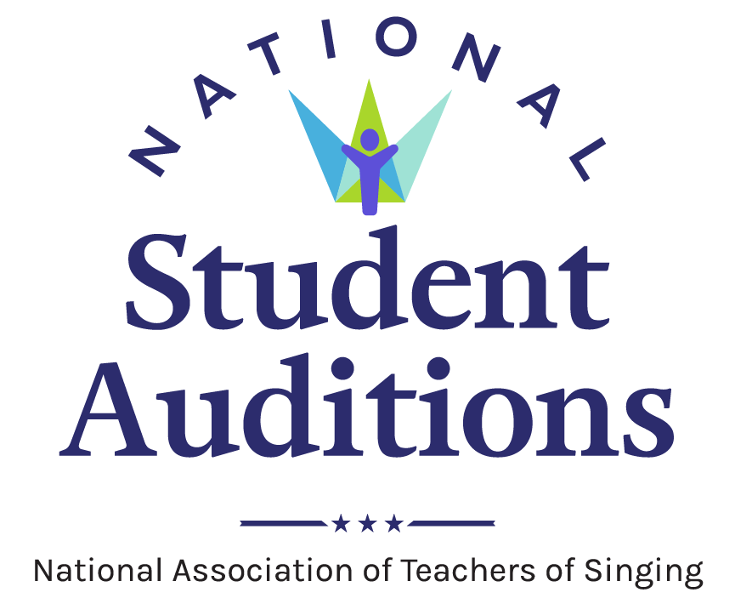
National Student Auditions Media Release Template
Media releases are important tools in sharing news and information about happenings and events taking place in your NATS chapter, district, or region. They allow the creator to package all important facts and details into a single document that can be easily shared and distributed, forming an important piece of the communication cycle.

Once completed, media releases should be distributed via media outlets, campus news organizations, campus PR/marketing offices, email, social media, websites, on bulletin boards, and anywhere else the news might be useful and easily accessed by the target audience. Keep the facts simple and remember to included the Who, What, When, Where, and Why in any document.

To assist in this effort, NATS has developed two media release templates for use by chapters, districts, and regions as they promote National Student Audition events in their area. One template offers a preview of the NATS Student Auditions event, while the other is a template for reporting results after the event concludes. Adjust these templates as needed and add any information that reflects the uniqueness of your local event.

Please contact the NATS Executive Office at info@nats.org or 904-992-9101 with any questions about these templates.
Purpose These media release templates are designed to assist NATS chapters, districts, and regions share information via news media about the various rounds of National Student Auditions.
Format These tools provide easy fill-in areas for localized information to be added. The areas to add personalized information are yellow highlight. Once completed, select the yellow highlight with your cursor. Navigate to the “Home” tab, then on drop-down menu of highlighter, select “No color.”
Audience This tool is designed to be distributed to local media outlets, campus media outlets, campus news and information bureaus, campus media relations offices, and as a template for news and information shared via chapter, district or region websites. The tools also may be adapted for other NATS purposes and the general public.
Resources Information about the event you plan to publicize using a media release.

For more information:
Contact Name, Phone, Email

For Immediate Release
Month-Day-Year

National Student Auditions – [Chapter/District/Region] selects top performers (Headline)

Additional details and information goes here (subhead)

CITY, State — (Month Day, Year). More than [number] singers in the [insert geographic location] area participated in the National Student Auditions offered by the National Association of Teachers of Singing (NATS).

Auditions were held [Month, Day] at [Name of University and/or location], with top performers selected in [number] categories.

Singers auditioned and received important feedback as part of the long-standing tradition of the National Association of Teachers of Singing (NATS) National Student Auditions program. Various musical styles were on display during the event, from musical theatre and commercial music to classical repertoire. The top three singers were selected in each category, as selected by a panel of three adjudicators. [Add prize, scholarship, or other information here, if applicable or desired.]

[Add a quote here if desired].

Top performers by category include:
1 – High School Musical Theatre Treble – [Name of winner, Name of Teacher, etc]
2 – High School Musical Theatre TBB – [Name of winner, Name of Teacher, etc]
3 – High School Treble – [Name of winner, Name of Teacher, etc.]
Etc

View the complete list of all top performers in each category: [insert hyperlink, or hyperlink the words “Complete list.”]

National Student Auditions have been an integral part of the association’s history. The auditions allow singers to receive important adjudication feedback and teachers the opportunity to engage in meaningful dialogue with colleagues and hear a variety of musical styles through live performance.

In order to participate in the National Student Auditions, a singer must be a student of a current NATS member. The singer’s participation category is determined by a variety of factors — including musical genre/style, the amount of time they have studied voice, age, and year in school. More than 80 NATS chapters hold these auditions each year from the organization’s 14 regions. Top performers in region auditions have an opportunity to advance to the national rounds of auditions. To learn more, visit nats.org.

How auditions work:

Region Auditions
In order to participate in the national rounds of these auditions, students of NATS members must qualify by performing during their region auditions. The top five singers from each eligible region category advance to the national online preliminary round.

National Preliminary Auditions
Each singer who advances from a region audition must apply and submit videos of their performances for adjudication by a panel of international judges in the national preliminary round.

National Semifinals and Finals
Fourteen singers from each of the 18 categories (plus the Hall Johnson Spirituals Competition during conference years and the American Negro Spirituals Categories every other year) advance to the national semifinal round.

From there, the top three singers from each category compete in the national final round. The national semifinal and final rounds will be held in conjunction with the NATS National Conference July 1-6, 2022 in Chicago, Illinois.
About the National Association of Teachers of Singing (NATS)
Founded in 1944, National Association of Teachers of Singing, Inc. (NATS) is the largest professional association of teachers of singing in the world with more than 7,000 members in the United States, Canada, and more than 30 other countries. NATS offers a variety of lifelong learning experiences to its members, with workshops, intern programs, master classes, and conferences, all beginning at the chapter level and progressing to national events. Visit nats.org to learn more about NATS.

###

